IFT 512 Advanced Big Data Analytics

Professor Robert Rucker

Sushmita Prafull Halasawade 1226584322

Trilok Navya Dubaka 1224487563

Weather Data Analysis Project

28th April 2023

**Introduction**

Analyzing weather data using PySpark can provide valuable insights into weather patterns and trends, which can have practical applications in various industries.

For instance, in the agriculture industry, knowing the weather patterns in a region can help farmers plan their crops and irrigation schedule accordingly. In the tourism industry, weather data can be used to optimize travel packages and recommend the best time to visit a particular destination.

In the case of disaster response, accurate weather data and predictions can help authorities prepare and respond appropriately. This information can help residents and authorities prepare for potential weather hazards, plan energy usage, and optimize building design. Weather data analysis can provide valuable insights into weather patterns and trends that can have practical applications in various industries and benefit society as a whole.

**Input :**

We would be using the city temperature dataset as the input with the attributes Region,Country, State, City, Month, Day, Year, AvgTemperature

**Job pipeline:**

* Ingestion of CSV files with the read method
* Cleaning the data by treating duplicates and Null values
* Filtering the data and selecting specific columns
* Performing custom computations with UDFs
* Running analytics and creating plots

We cleaned and filtered the data, performed custom computations on the dataset with UDFs to run analytics.

**Actionable decisions:**

After running the analytics we then created the plots with the data that will help the organizations like agriculture industry, tourism industry, disaster response etc.,

* Agriculture: Farmers can use weather analysis to decide when to plant crops, how much to water them, and when to harvest them. For example, if a region is experiencing a drought, farmers can adjust their irrigation practices to conserve water and ensure their crops survive.
* Transportation: Airlines can use weather analysis to make decisions about flight routes, departure times, and aircraft maintenance. For example, if there is a major storm in a particular region, airlines may need to reroute their flights to avoid the weather and minimize delays.
* Emergency Services: Emergency services such as fire departments and police can use weather analysis to prepare for and respond to natural disasters such as hurricanes, tornadoes, and wildfires. They can also use weather analysis to plan for extreme weather events such as heatwaves and cold snaps.

**2. What actionable decision(s) would you anticipate from your work?**

Here are five example questions that a weather analysis PySpark project with weather data could address, which could have organizational benefits:

1. What are the overall temperature patterns over the years, and how do they compare to other cities?

This information can be useful for the tourism industry in recommending the best time to visit the place, as well as for city planners in designing and optimizing building infrastructure and energy usage.

1. What are the monthly trends in temperature?

This information can be beneficial for farmers in planning their crops and irrigation schedule and optimizing their yields.

1. What are the Average Temperature in Phoenix in different seasons - season trends?

This information can be beneficial for farmers in planning their crops and irrigation schedule and optimizing their yields in different seasons.

This information can be useful for building managers and city planners in designing and optimizing building infrastructure and energy usage.

1. What are the average temperature in US? What implications does this have for the region's infrastructure and economy?

This information can be useful for policymakers and city planners in developing sustainable and resilient infrastructure and economic policies.

1. Can we predict extreme weather events, such as heavy rain or snow, in advance to better prepare for them?

This information can be useful for disaster response teams in preparing and responding appropriately to potential weather hazards.

1. How do weather patterns impact energy usage in buildings, and how can we optimize energy usage based on these patterns?

This information can be useful for building managers and city planners in designing and optimizing building infrastructure and energy usage.

3. **What data set(s) are you proposing to use?**

We have used city temperatures dataset –

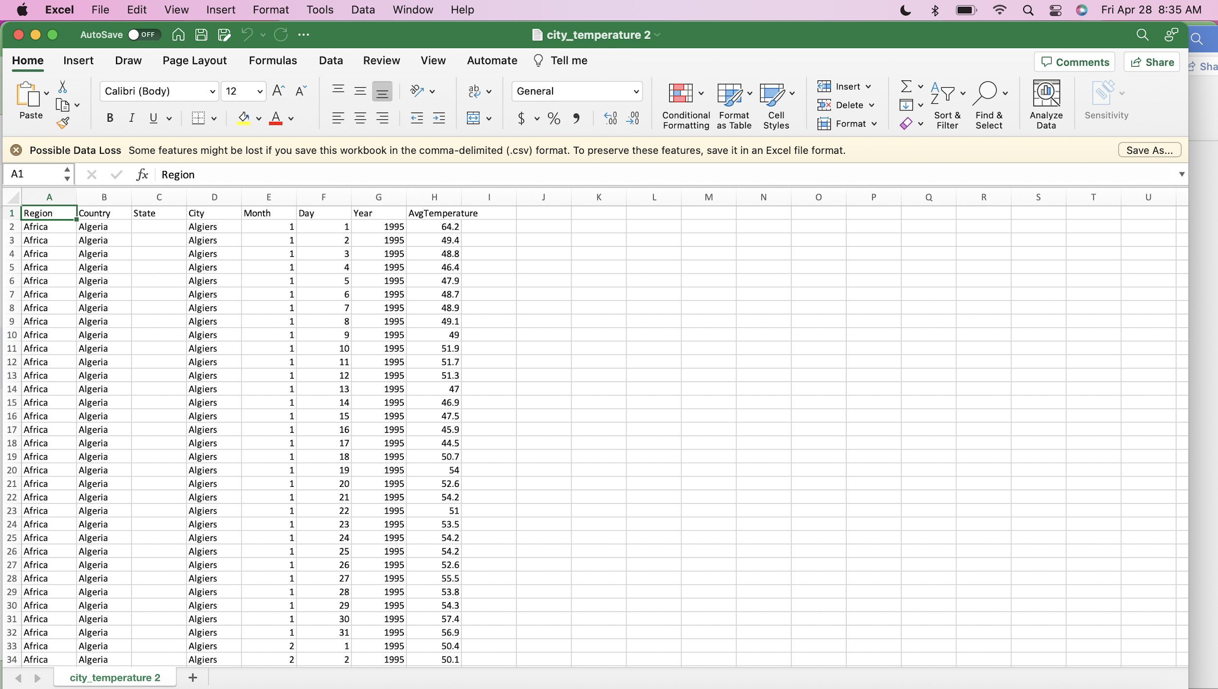

It has the attributes :

Region

Country

State

City

Month

Day

Year

AvgTemperature

4. **Proposed job pipeline flow. From data extraction, preparation, exploration …??… model(s), evaluation, presentation(s), deployment? (CRISP model as a guide)**

In the case of this weather analysis PySpark project with weather dataset, the proposed steps align with the CRISP-DM framework as follows:

1. Business Understanding: The business objective of the project is to gain insights into weather patterns and trends which can be useful for various stakeholders, such as meteorologists, city planners, and transportation providers.
2. Data Understanding: The data available for the project includes weather datasets, which contain information on temperature, precipitation, wind speed, humidity, atmospheric pressure, and other weather variables.
3. Data Preparation: The data preparation step involves cleaning and transforming the data to make it suitable for analysis. This may include removing missing values, converting data types, and aggregating data by time periods.
4. Modeling: The modeling step involves applying appropriate statistical models to the data to develop insights and predictions. This may include trend analysis, time series forecasting, and clustering analysis.
5. Evaluation: The evaluation step involves assessing the performance of the models and their effectiveness in meeting the business objectives. This may include comparing the models to historical data or external benchmarks.
6. Deployment: The deployment step involves presenting the findings and insights to the business stakeholders in a clear and actionable manner, which can inform decision-making and planning processes.

Overall, the proposed PySpark project for weather analysis with weather dataset matches the CRISP-DM framework in terms of its systematic and structured approach to data mining and analysis.

**5. Proposed estimators and models to be employed, i.e will this have a classification, (lin/log)regression, graphical, deep learning , or a clustering focus? Or will it be a combination?**

we would propose using the following technologies:

1. PySpark: PySpark is a distributed computing framework that can handle large datasets in a parallelized fashion. It provides a Python API for programming Spark, which can simplify data processing and analysis.
2. Apache Spark: Apache Spark is a distributed computing framework that can handle large datasets in a parallelized fashion. It provides a unified analytics engine for big data processing, machine learning, and streaming workloads.
3. Pandas: Pandas is a Python library for data manipulation and analysis. It provides data structures for efficiently handling large datasets, as well as functions for data cleaning, filtering, and aggregation.
4. Spark SQL: Spark SQL is a Spark module for structured data processing. It provides a programming interface to work with structured data using SQL or DataFrames.
5. Matplotlib: Matplotlib is a Python library for data visualization. It provides functions for creating a variety of charts and graphs, including line charts, bar charts, and scatter plots.
6. Seaborn: Seaborn is a Python library for statistical data visualization. It provides functions for creating more complex and sophisticated visualizations, such as heatmaps, histograms, and regression plots.

**Estimators and models employed:**

* The choice of estimator and models to be used in a PySpark-based weather analysis project depends on the specific research questions and objectives of the analysis. In general, a combination of different models and techniques may be employed to gain insights into weather patterns and trends.
* In our Analysis we have employed the AutoRegression Model. It is often necessary to quickly and efficiently calculate time series values to assess the behavior of an observed object or process. This can be an indicator of the company's performance in a certain direction, the temperature inside the room, the cost of a certain product for a promotion, an assessment of customer satisfaction with service, and so on.
* A time series (or a dynamic series) is statistical material collected at different points in time about the value of any parameters (in the simplest case, one) of the process under study. Each unit of statistical material is called a measurement or data sample at a specific moment in time.
* The time series for each sample must indicate the measurement time or the number of measurements in order. A time series differs significantly from a simple data sample since the analysis takes into account the relationship of measurements to time, and not only the statistical diversity and statistical characteristics of the sample.
* A time series consists of two elements:

the period of time for which or as of which the numerical values are given;

numerical values of one or another indicator called the levels of the series.

* A time series can be classified by the number of indicators for which the levels are determined at each point in time: one-dimensional and multi-dimensional time series.
* Also, time series are divided depending on the presence of the main trend, while stationary series, in which the main value and variance are constant, and non-stationary ones, containing the main development trend, are distinguished.

**6. Code and results included :**

**Reading the dataset:**

**Code:**

import warnings

warnings.filterwarnings('ignore')

from datetime import datetime

import numpy as np

import pandas as pd

import matplotlib.pyplot as plt

import seaborn as sns

#Reading the dataset

df = spark.read.option("header",'true').csv("/FileStore/tables/city_temperature.csv",inferSchema=True)

print(df.dtypes)

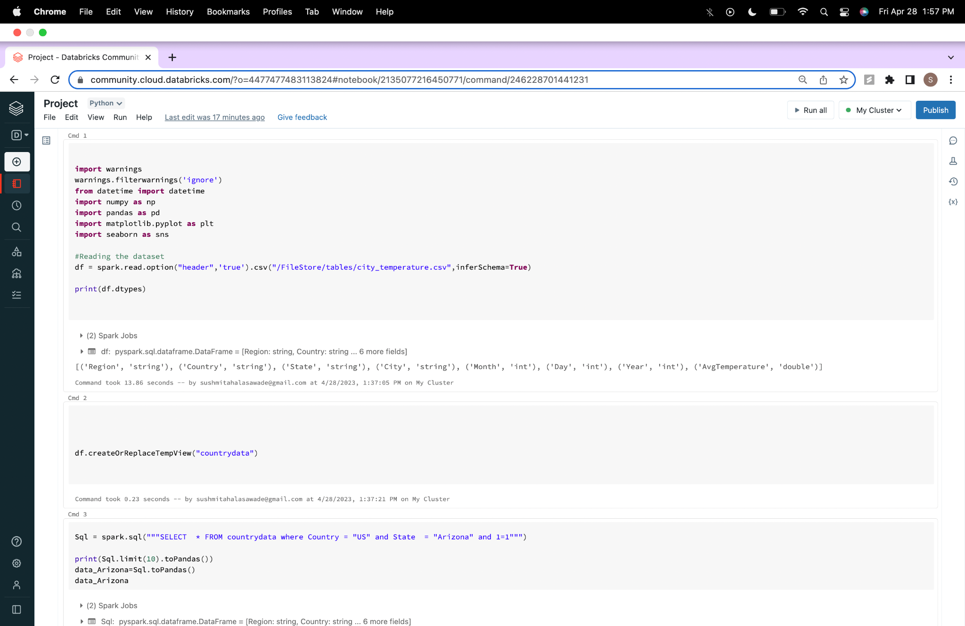

[('Region', 'string'), ('Country', 'string'), ('State', 'string'), ('City', 'string'), ('Month', 'int'), ('Day', 'int'), ('Year', 'int'), ('AvgTemperature', 'double')]

**Using spark.sql:**

**Code:**

#Creating the spark table

df.createOrReplaceTempView("countrydata")

Sql = spark.sql("""SELECT * FROM countrydata where Country = "US" and State = "Arizona" and 1=1""")

print(Sql.limit(10).toPandas())

data_Arizona=Sql.toPandas()

data_Arizona

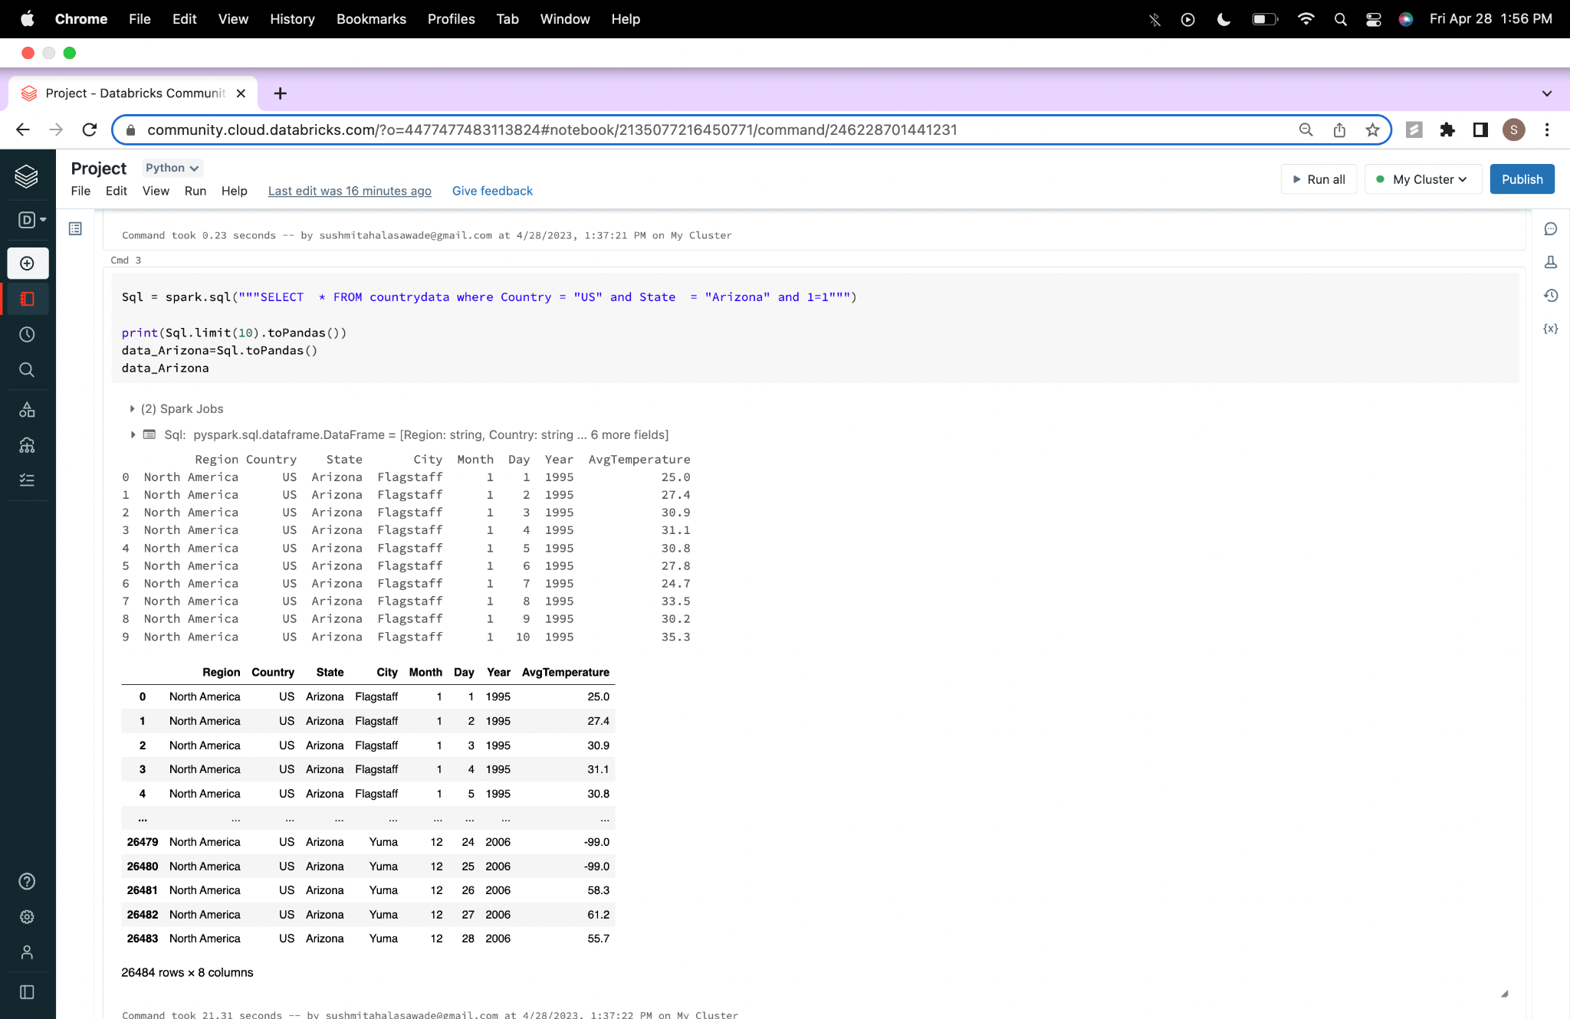

**Comparison of temperatures in the four cities in Arizona:**

(Phoenix, Flagstaff, Tucson, Yuma)

**Code:**

#plot for 4 cities and comparison of their temperatures

sns.set_style('ticks')

Arizona_plot=data_Arizona.groupby(['City','Year'])['AvgTemperature'].mean().reset_index()

Arizona_plot.pivot('Year','City','AvgTemperature').plot()

plt.title('Average Temperature Arizona- Yearly trend',fontsize=20);

plt.gcf().set_size_inches(14,6)

plt.show()

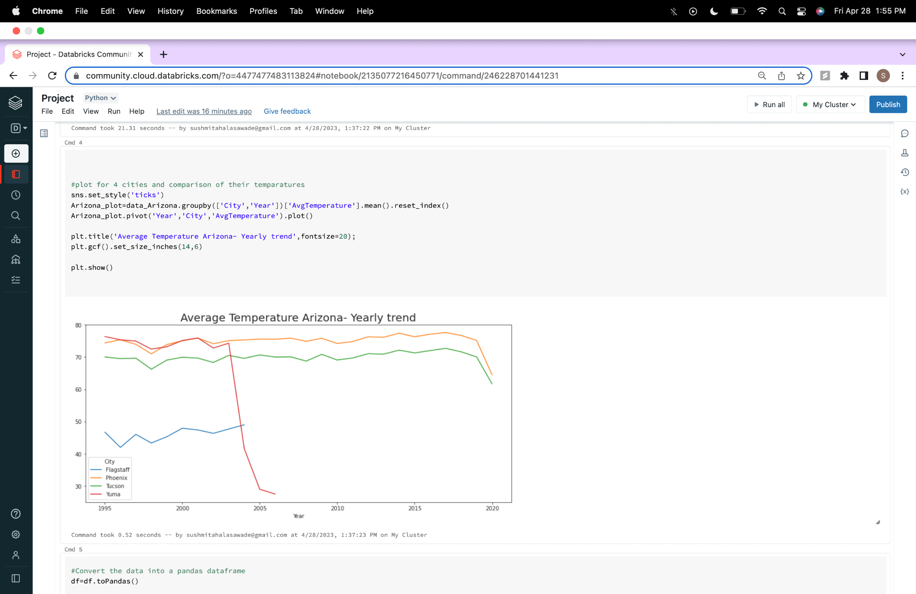

#Converting the data into pandas dataframe

df=df.toPandas()

#Choosing only the rows with US from the dataframe

data_US = df[ (df['Country'] == 'US')]

**Data Preprocessing :**

**Code:**

#Eliminating the invalid temperature -99

## data preprocessing

data_US["AvgTemperature"].replace(-99, np.mean(data_US["AvgTemperature"]), inplace = True)

**Montly Average temperature :**

**Code:**

#Average temparature monthly in US

plt.figure(figsize= (15,10))

sns.pointplot(x='Month', y='AvgTemperature', data=data_US);

plt.title('Average Temperature US - Monthly Trend',fontsize=20);

plt.show()

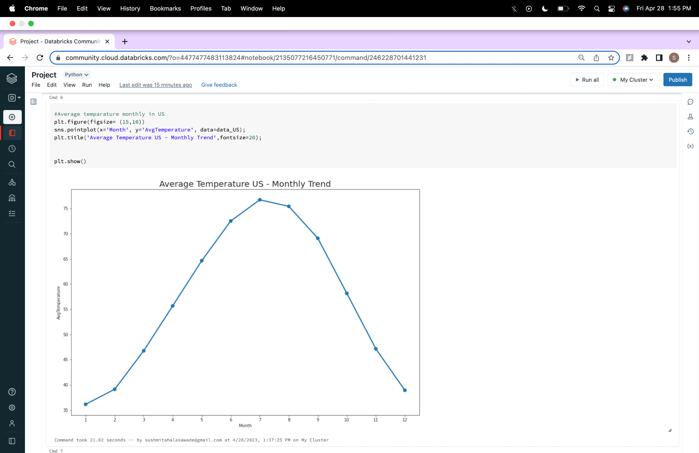

**Average Temperature in Phoenix for four seasons (creating season UDF) :**

**Code:**

#creating variable 'season'

def season(df):

if df in [12,1,2] :

return 'Winter'

elif df in [3,4,5]:

return 'Spring'

elif df in [6,7,8]:

return 'Summer'

elif df in [9,10,11]:

return 'Autumn'

else:

return 'NA'

pd.options.mode.chained_assignment = None # default='warn'

data_US['Season'] = data_US['Month'].apply(season)

data_US['AvgTemperature']=data_US['AvgTemperature'].astype('float64')

data_US[['Month' , 'Day' , 'Year']]=data_US[['Month' , 'Day' , 'Year']].astype('int64')

#Seasons in phx

data_phx = data_US[data_US['City'] == 'Phoenix']

#Plot the seasons

Phoenix_plot=data_phx.groupby(['Season','Year'])['AvgTemperature'].mean().reset_index()

Phoenix_plot.pivot('Year','Season','AvgTemperature').plot()

plt.gcf().set_size_inches(14,6)

plt.title('Average Temperature Phoenix - Season Trend',fontsize=20);

plt.show()

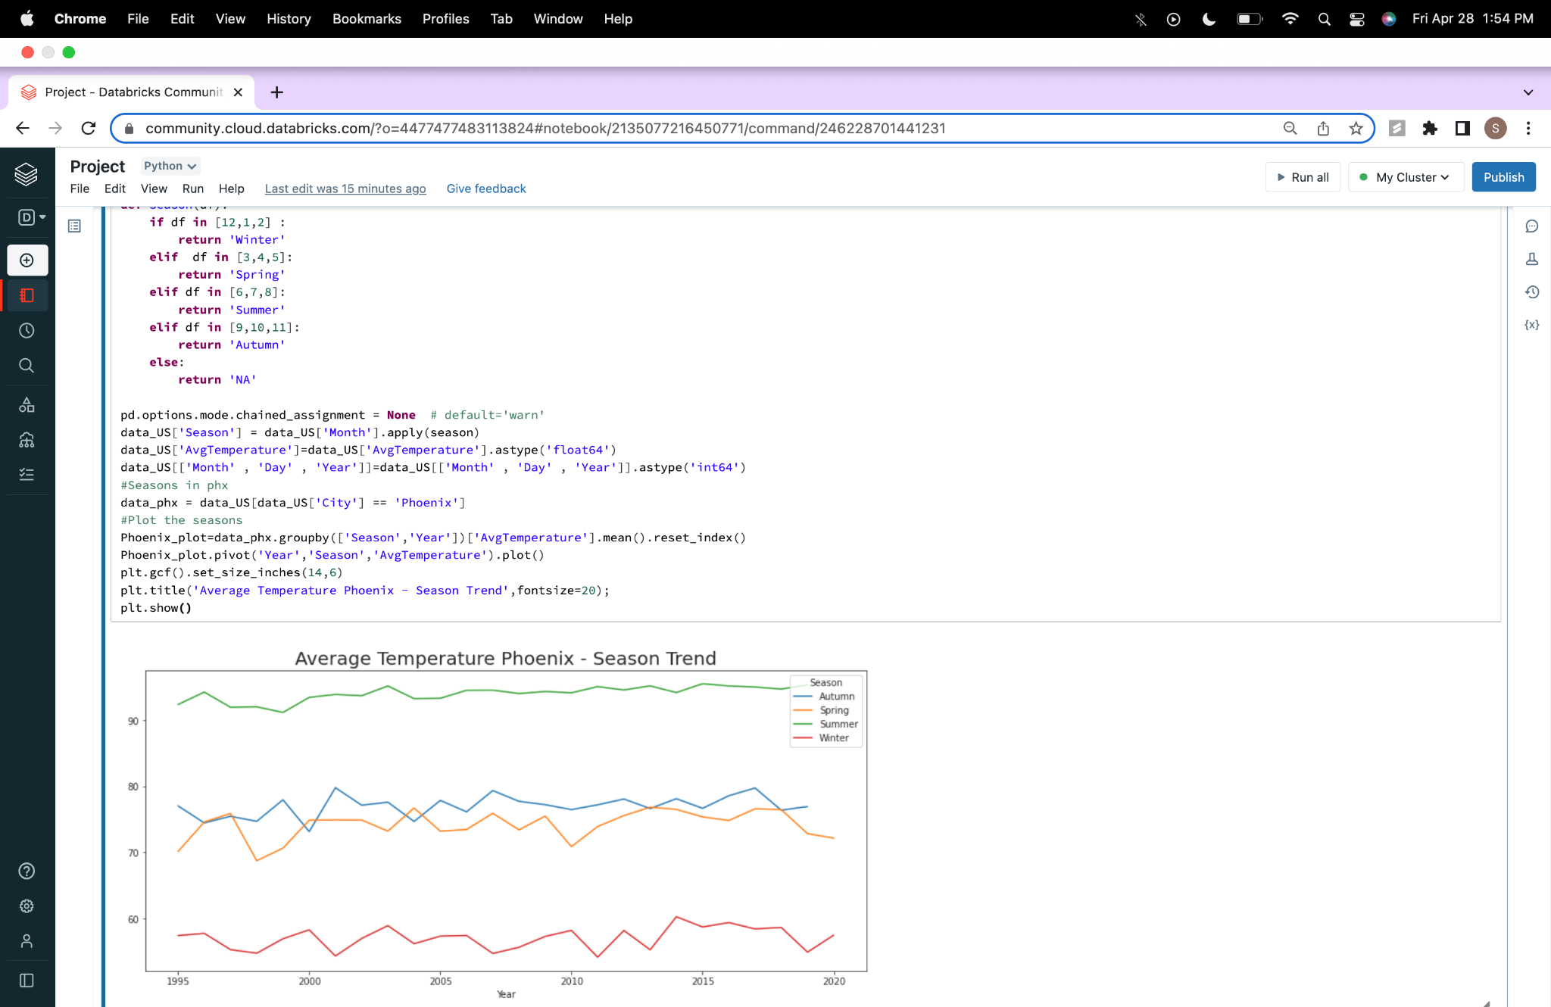

**Average Temperature in Phoenix over the years (with temp_type udf):**

**Code:**

def temp_type(df):

if (df is None):

return "unknown"

else:

if df < 14:

return "freezing cold"

elif df < 23:

return "very cold"

elif df < 32:

return "cold"

elif df < 50:

return "normal"

elif df < 68:

return "warm"

elif df < 86:

return "hot"

elif df >= 86:

return "very hot"

return "normal"

pd.options.mode.chained_assignment = None # default='warn'

data_US['temp_type'] = data_US['AvgTemperature'].apply(temp_type)

data_US['date'] = pd.to_datetime(dict(year=data_US.Year, month=data_US.Month,day=data_US.Day))

#temp_type in phx

data_phx = data_US[(data_US['City'] == 'Phoenix') ]

## replacing outliers to mean

data_phx_2000 = data_phx[(data_phx['Year'] >= 2000)]

#Plot the temp_type

Phoenix_plot=data_phx_2000.groupby(['temp_type','date'])['AvgTemperature'].mean().reset_indx(Phoenix_plot.pivot('date','temp_type','AvgTemperature')

sns.scatterplot(hue="temp_type", y="AvgTemperature", x="date", data=Phoenix_plot,palette="Spectral_r")

plt.gcf().set_size_inches(28,8)

plt.title('Average Temperature Phoenix ',fontsize=20)

plt.show()

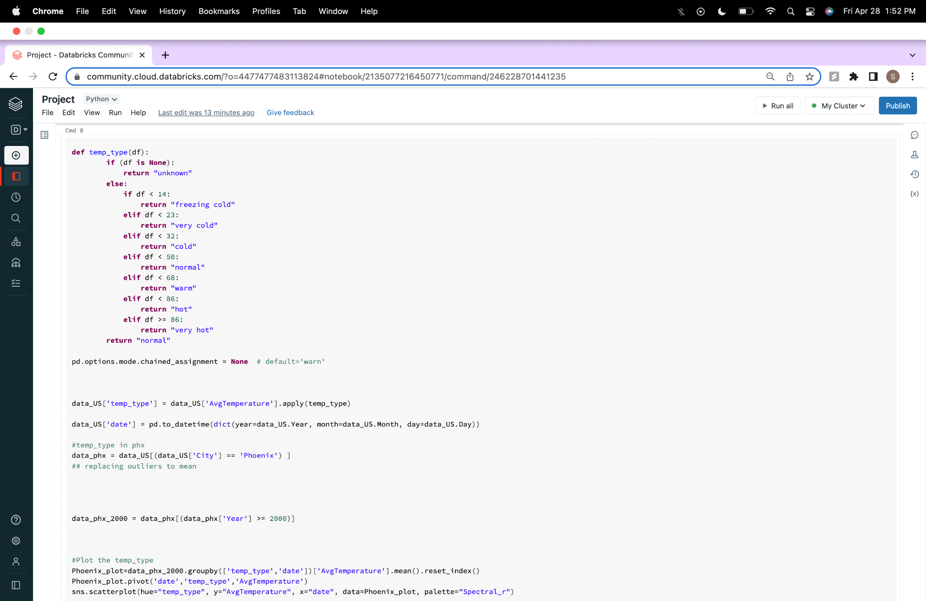

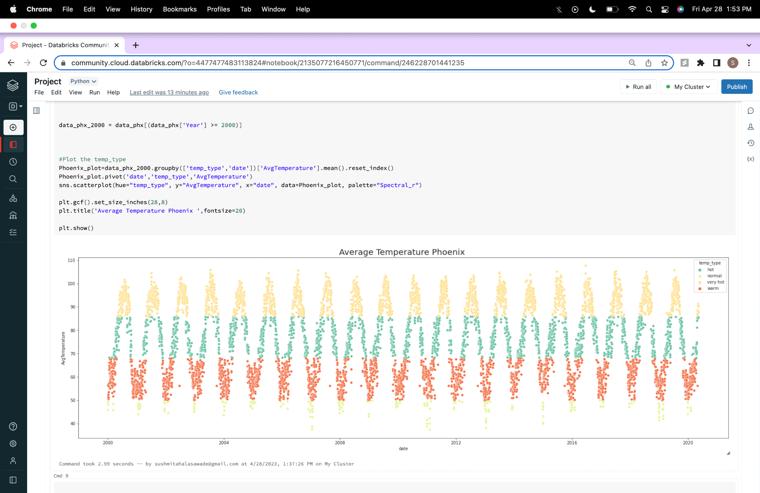

**Regionwise Average Temperature in Phoenix –**

**Code:**

# regionwise distribution

Average_Temperture_in_every_region = df.groupby("Region")["AvgTemperature"].mean().sort_values()[-1::-1]

Average_Temperture_in_every_region =Average_Temperture_in_every_region.rename({"South/Central America & Carribean":"South America","Australia/South Pacific":"Australia"})

Average_Temperture_in_every_region

fig3= plt.figure(figsize = (15,8))

plt.bar(Average_Temperture_in_every_region.index,Average_Temperture_in_every_region.values)

plt.xticks(rotation = 10,size = 15)

plt.yticks(size = 15)

plt.ylabel("Average_Temperture",size = 15)

plt.title("Average Temperture US - regionwise",size = 20)

plt.show()

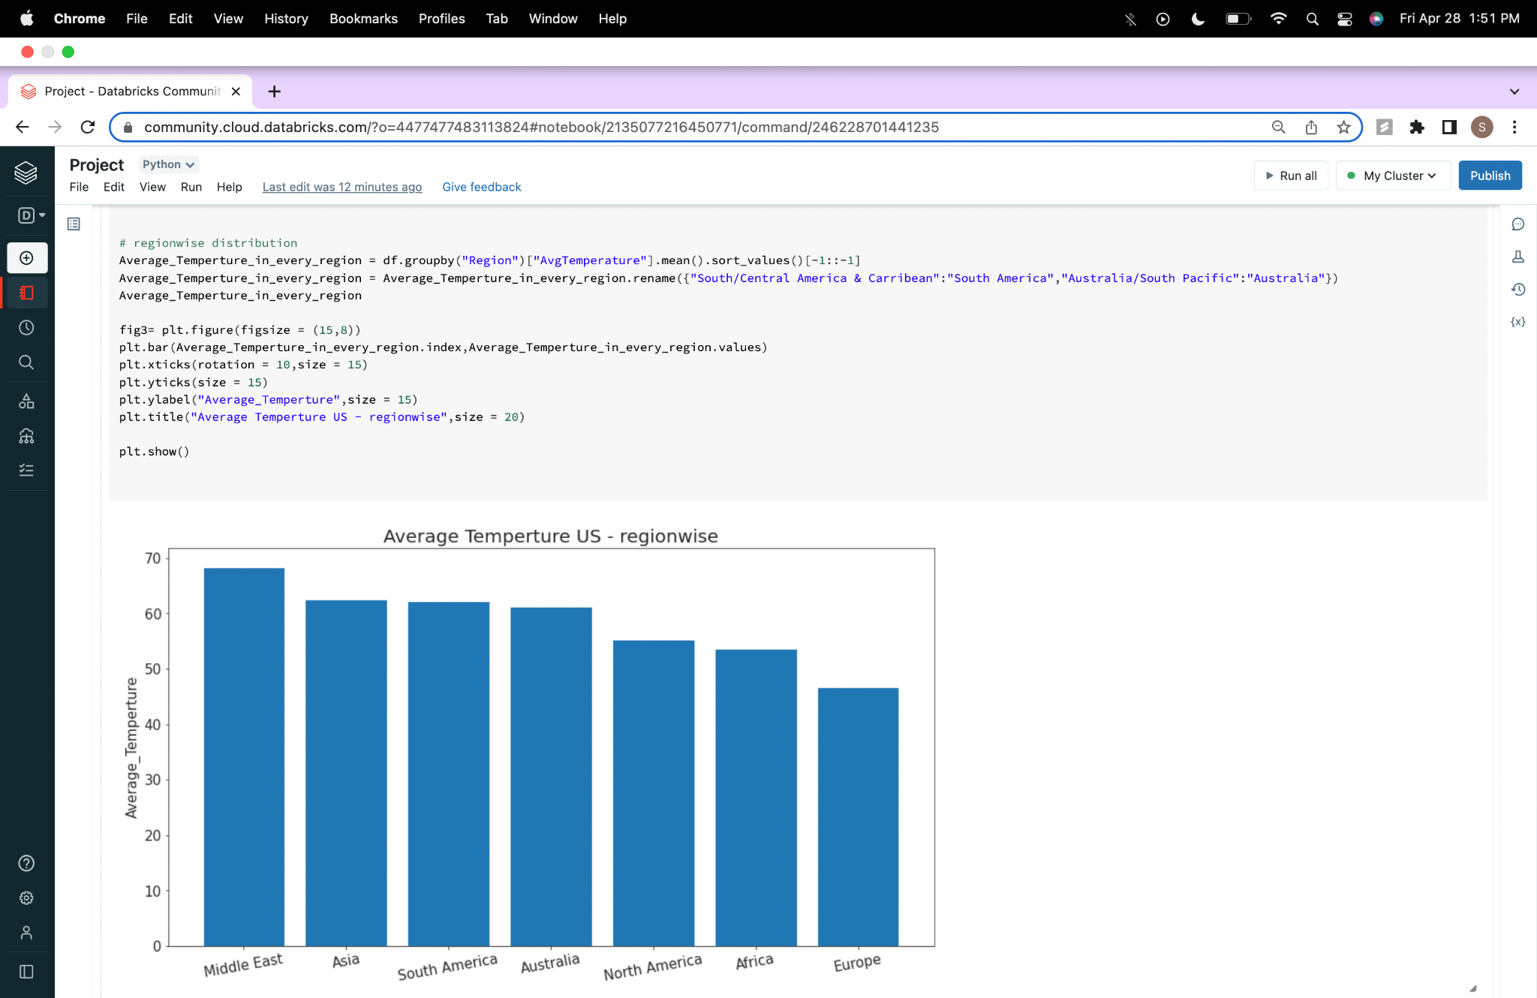

**Training and testing set:**

**Code:**

#Defining training and testing data

phx = data_US[data_US["City"] == "Phoenix"]

phx.reset_index(inplace = True)

phx.drop('index', axis = 1, inplace=True)

phx = phx.drop(['Region', 'Country', 'State','City','Month','Day','Season', 'temp_type'], axis = 1)

training_set = phx[phx["Year"] <= 2010]

test_set = phx[phx["Year"] > 2010]

training_set

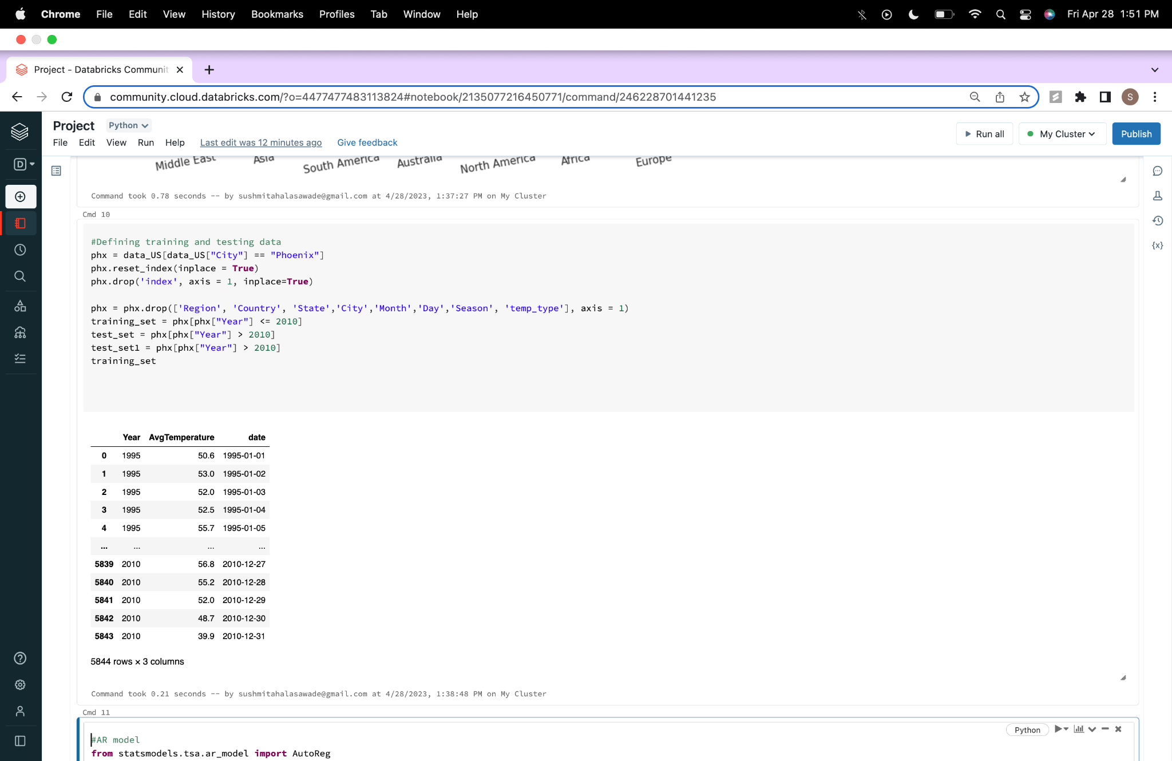

**Implementing AutoRegression and Finding out the error:**

**Code:**

#AR model

from statsmodels.tsa.ar_model import AutoReg

from sklearn.metrics import mean_squared_error

model_AR = AutoReg(training_set["AvgTemperature"], lags = 1000)

model_fit_AR = model_AR.fit()

predictions_AR = model_fit_AR.predict(training_set.shape[0], training_set.shape[0] + test_set.shape[0] - 1)

import seaborn as sns

fig6= plt.figure(figsize=(15,5))

plt.ylabel("Temperature (F)", fontsize = 20)

plt.plot(test_set["AvgTemperature"], label = "Original Data")

plt.plot(predictions_AR, label = "Predictions")

plt.legend()

plt.show()

rmse = mean_squared_error(predictions_AR,test_set["AvgTemperature"])

print(rmse**0.5)

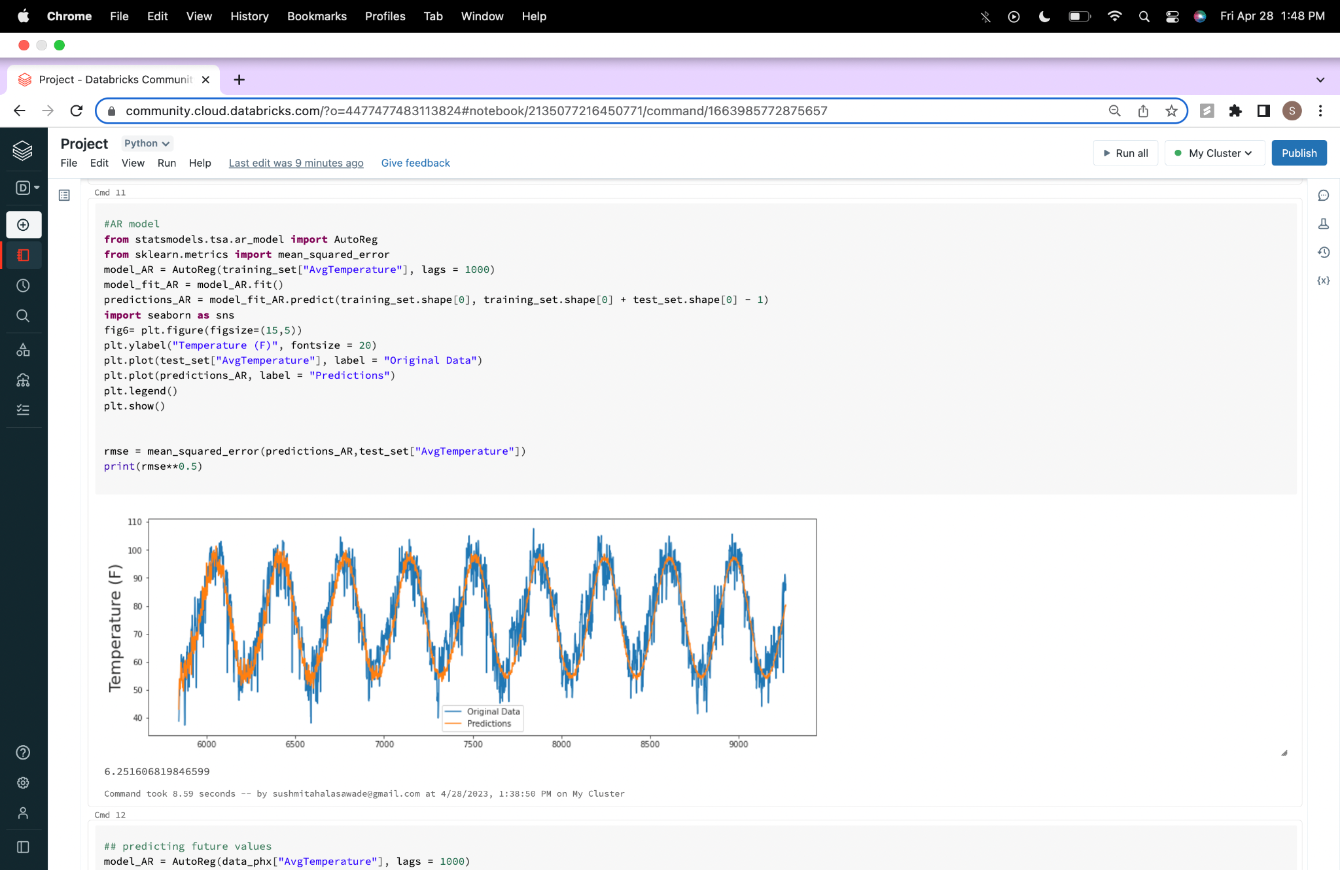

**Predicting future Temperatures :**

**Code:**

## predicting future values

model_AR = AutoReg(data_phx["AvgTemperature"], lags = 1000)

model_fit_AR = model_AR.fit()

y = model_fit_AR.predict(len(data_phx["AvgTemperature"]), len(data_phx["AvgTemperature"])+500)

print(y)

plt.figure(figsize=(10,5))

prognose = np.concatenate((data_phx["AvgTemperature"],y))

plt.plot(range(1,len(prognose)+1), prognose, 'r')

plt.plot(range(1,len(data_phx["AvgTemperature"])+1), data_phx["AvgTemperature"], 'b')

plt.show()

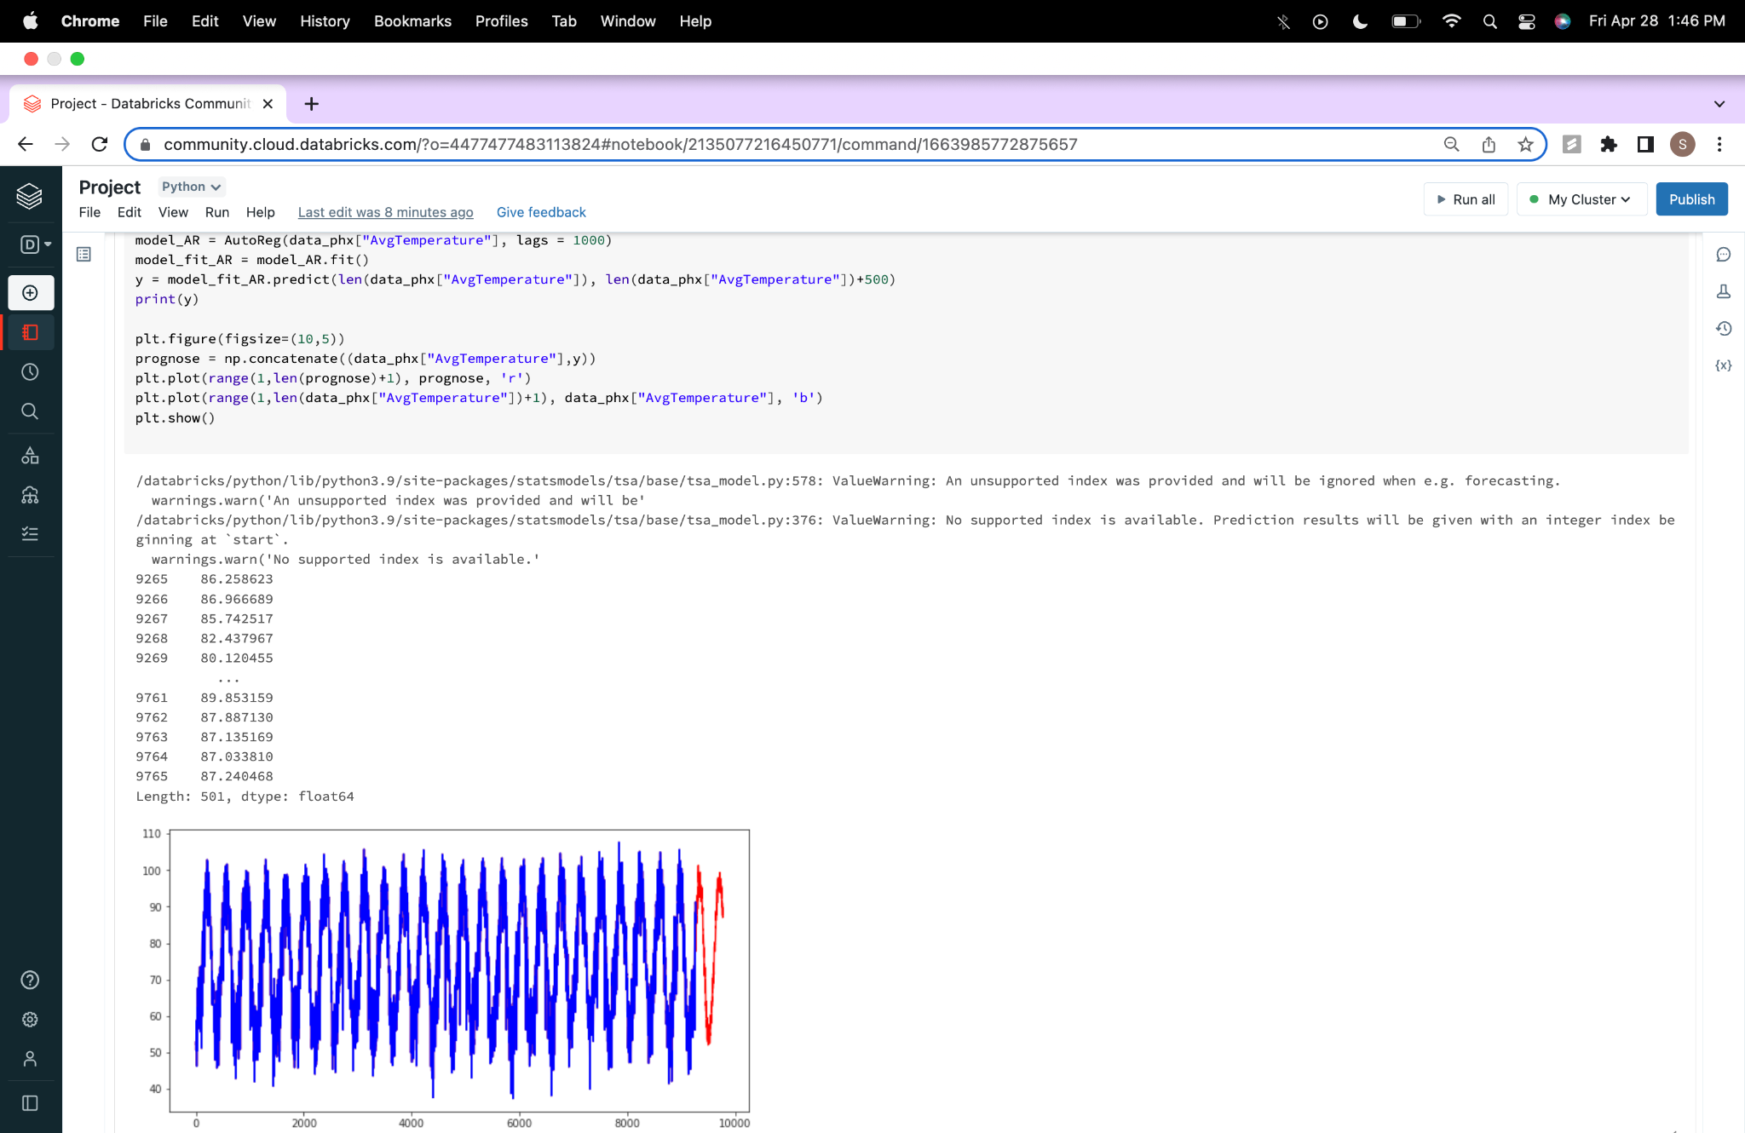

**Implementation of linear regression in pyspark:**

**Code:**

# using spark

from pyspark.sql.functions import col

from pyspark.ml.regression import LinearRegression

import pandas as pd

from pyspark.ml.feature import VectorAssembler

from pyspark.ml.evaluation import RegressionEvaluator

# convert Pandas DataFrame to Spark DataFrame

training_set_spark = spark.createDataFrame(training_set)

test_set_spark = spark.createDataFrame(test_set)

# Assemble the feature vector

assembler = VectorAssembler(inputCols=["AvgTemperature"], outputCol="features")

training_features = assembler.transform(training_set_spark).select(col("features"), col("date"), col("AvgTemperature").alias("label"))

test_features = assembler.transform(test_set_spark).select(col("features"), col("date"), col("AvgTemperature").alias("label"))

# Train the linear regression model

lr = LinearRegression(featuresCol="features", labelCol="label" ,elasticNetParam=0.5, regParam=0.01)

model = lr.fit(training_features)

##dt = DecisionTreeRegressor(featuresCol="features", labelCol="label", maxDepth=5)

##model = dt.fit(training_features)

# Make predictions on the test set

predictions = model.transform(test_features).orderBy("date")

# Convert predictions to Pandas DataFrame for plotting

predictions_pd = predictions.select("date", "prediction").toPandas()

# Compute the RMSE

evaluator = RegressionEvaluator(labelCol="label", predictionCol="prediction", metricName="rmse")

rmse = evaluator.evaluate(predictions)

print(rmse)

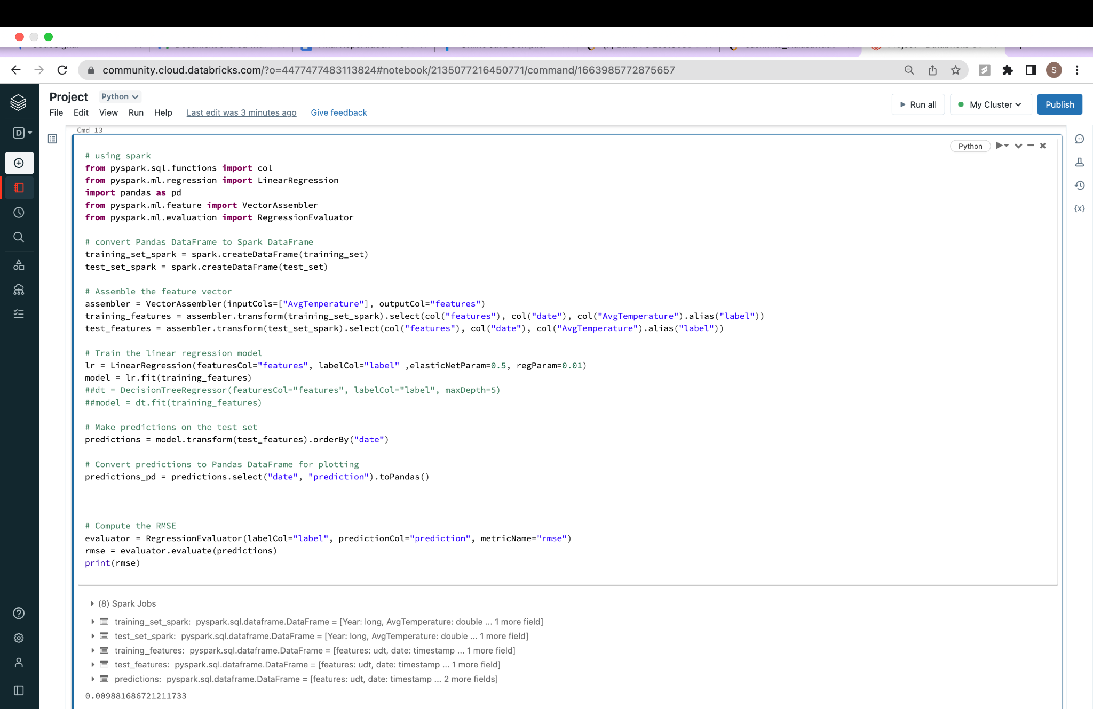

**Code:**

# Plot the data

fig6 = plt.figure(figsize=(15,5))

plt.ylabel("Temperature (F)", fontsize = 20)

plt.plot(test_set1["date"], test_set1["AvgTemperature"], label = "Original Data")

plt.plot(predictions_pd["date"], predictions_pd["prediction"], label = "Predictions")

plt.legend()

plt.show()

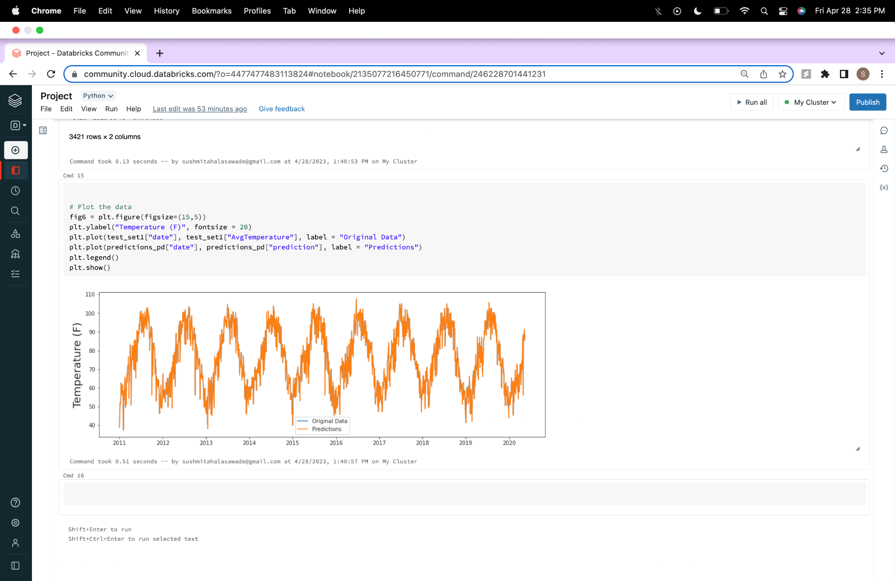

**7. Infrastructure:**

We used python with the below technologies: PySpark, Apache Spark, Pandas, Spark SQL, Matplotlib, Seaborn

Spark

As mentioned earlier, linear regression or logistic regression models are used to model the relationship between weather variables such as temperature and humidity.

The autoregressive model determines that the output variable is linearly dependent on its own previous values and on the stochastic term (responsible for a parameter that cannot be fully predicted). The model takes the form of a stochastic difference equation (or a recurrence relation, but not in the form of a differential equation).

We used graphical techniques such as data visualization to explore relationships and patterns in the data.

**8.Summary:**

The proposed project involves analyzing weather data using PySpark technology.

We have pre-processed the data and

We have presented graphical representations of –

* Temperatures of 4 cities and their comparison.
* Average temperature monthly
* Average temperature in Phoenix - season trend
* Implemented a user defined function to show graph for average temperature in Phoenix
* Average temperature US region-wise
* Implemented autoregression model to find the test error
* Predicted the future temperatures.

The purpose of this project is to gain insights into weather patterns and trends that can be useful for various stakeholders, such as meteorologists, city planners, and transportation providers.

The project will involve several steps aligned with the CRISP-DM framework, including business understanding, data understanding, data preparation, modeling, evaluation, and deployment.

The data set used for the analysis will include weather data which contains information on temperature, precipitation, wind speed, humidity, atmospheric pressure, and other weather variables.

The proposed technologies for the project include PySpark, Python, and various data visualization tools.

Overall, this project has several potential organizational benefits, such as improving planning and decision-making processes related to weather and enhancing the efficiency and effectiveness of various industries and sectors.

**9. Conclusion:**

Weather analytics projects using Spark can be highly valuable for a variety of industries and in many use cases. By leveraging the power of big data and advanced analytics algorithms, organizations can gain valuable insights into weather patterns and make more informed decisions.

Weather analytics with Spark is a powerful tool for unlocking insights and improving decision-making in a wide range of industries. By leveraging the power of big data and advanced analytics algorithms, organizations can gain a competitive edge and improve outcomes for their customers and stakeholders.